TUCSON SIMULATION
BRIEFING AND SCRIPT

Standard Operating Procedures
Tucson Interagency Dispatch Center

Administrative
The Tucson Interagency Dispatch Center (AZ-TDC) is in the Southwest Geographic Area. The Southwest Coordination Center (SWCC) is in Albuquerque, NM. These Standard Operating Procedures (SOP) are the guidelines for how this office operates daily.
Situation and Tactical Resource Reports
Each morning the Incident Management Situation Report, Southwest Morning Situation Report, and SWCC Tactical Resource Reports should be referenced to maintain situational awareness of existing and new activity and impacts on resource capability outside of the Tucson Dispatch area.
Reporting
Each evening the Situation Report should be completed and submitted prior to 1900. with each unit to ensure correct information for resources available and fire status when doing the evening Situation Report.
Fire Reporting Procedures
Most of the smoke reports and fires are reported by either air patrol or the lookouts and occasionally by the public. Prompt response to these calls is expected as well as the use of pre-identified forms for this office. Notification to the duty officer should be made as soon as possible of confirmed fires.
Lookouts
Lookouts call in smoke reports, act as human relays to field personnel with radio traffic and can give weather information as well. The lookouts are listed below.
List Lookouts
Initial Report
There is a form to take the information on when receiving calls. Ask questions to complete the Fire Detection Report as much as possible. Use this information to dispatch the appropriate and available resources to the incident.
Initial Size-up
Once an Incident Commander is on scene, they will give an initial size-up of the fire situation. Use the Initial Action Fire Size-up form (see next page).
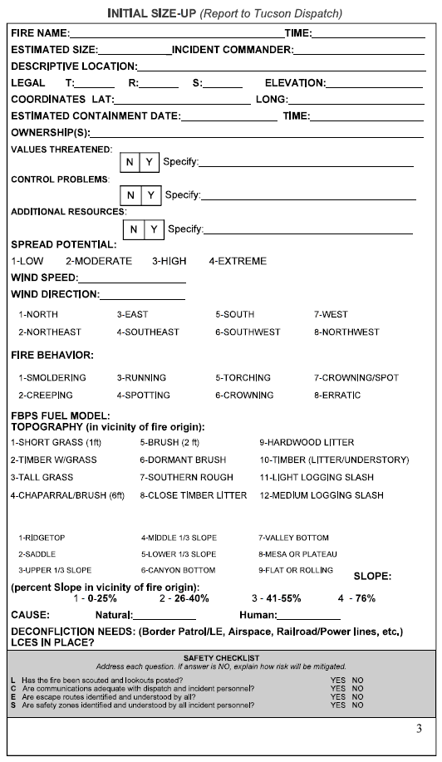

(Add a couple sentences for Tone-out info here, what it is, used for, etc.)
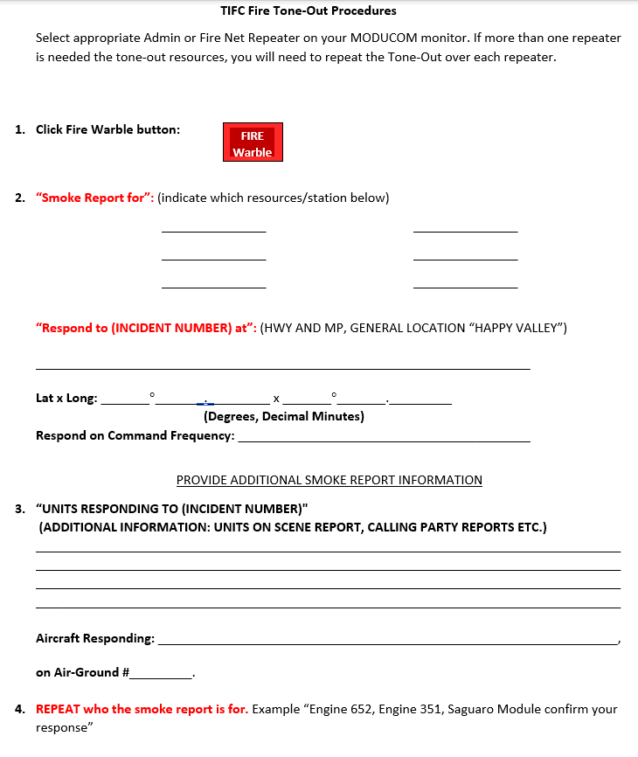

Fire Management/Duty Officers
CNF FMO Clyde Johnson
CNF Nogales District FMO Tyler Christianson
BLM FMO Tim Maloney
Firecodes and Incident Numbering
Tucson Dispatch will use CAD for incident numbering for each jurisdiction.
Tucson Dispatch will use CAD to pull incident Firecodes as applicable.
Burn Permits
Each morning the dispatch office receives a list of burn permits issued within the zone. These will be posted and referred to when receiving reports of smokes. This can eliminate sending resources out to false alarms.
Law Enforcement
The Coronado National Forest (CNF) has three Law Enforcement Officers (LEO). They periodically call the dispatch office for status checks when making contacts with the public. Document times and to whom you are talking with, as well as their location. The LEOs generally do not use their names on the radio, but instead have call signs. This is for safety reasons; please do not call them by their given name over the radio.
Name Call Sign
Devin Wilde 211
Trey Hammer 212
Nancy Moorehead Coronado - 10

EMS And Accident Reporting Procedures
All response to any emergency medical situations, accidents, or an incident within an incident will be documented in the Dispatch Log and reported immediately to the supervisor or center manager on shift. The county sheriffs’ office is responsible for all search and rescue operations. The appropriate county office will be notified in the event of an emergency medical situation that has been reported to the Tucson Dispatch Center. Dispatch will take as much information as they can about the type of accident, location and injured persons involved. This information should be relayed immediately. Requests for assistance from Tucson Dispatch will need to be documented in the Dispatch log and relayed to the center manager.

County Sheriffs’ Offices
Santa Cruz County Sheriffs’ Office
Cochise County Sheriffs’ Office
Pima County Sheriffs’ Office
Flight Following
The National Flight Following Frequency will be used when flights are transitioning through the dispatch area on agency flight plans. For aerial detection it is best to use the Direct or RED channel. Aircraft will check in at 15-minute intervals. Dispatch will keep a timer and check-in location documented for each aircraft they are flight following. Reference the National Interagency Standards for Resource Mobilization for more general information on flight following.
Daily Weather
Daily weather reports are posted on the Tucson NWS (National Weather Service) website at 0800 and 1530. Ensure that any and red flag watches and warnings are broadcast to the field. Ensure that all Incident Commanders (IC) on any ongoing fires have copied your broadcast.
Spot Forecasts
The spot forecast form should be filled out when a request comes in from the field. This will be entered into the Internet site and followed up by a call to the Tucson Weather Service. Once received, this must be transmitted back to the requesting party or IC without delay.
Media Calls
Please refer media calls to the Supervisor or Center Manager. They will answer the questions or refer to the Public Affairs Officer Janet Jackson if the incident escalates to a type one or two complexity.
Other Contacts
Campground Host - George Pedersen @ Parker Canyon Lake Campground
Arizona Fish & Game
Martha Stalwart @ Tucson Office

Aerial Resources
Aerial Detection
Aerial detection routes are determined by an FMO daily if needed. However, the aircraft may be requested to deviate at any time during the flight to check out a smoke report. Upon discovery of a new fire, the aerial observer will provide the initial size-up.
The following aircraft are available and carded for use in aerial detection. They are located at the Tucson Airport.
Cessna 182, N2919K - Sonoran Desert Aircraft Services
Airtankers
Contact the Southwest Coordination Center Aircraft Desk to request airtankers and aerial supervision. Use standard dispatch ordering forms and procedures.
Helicopters
The CNF has one EU Type 3 helicopter in Tucson with a 10-person helitack crew. Call the CNF Fire Management Officer to request this resource when needed. Additional helicopters can be ordered through the Southwest Coordination Center Aircraft Desk.

Ground Resources
Equipment
Engine 621, Type 6, Stationed at Nogales RD, Coronado NF. Engine Boss is John Beckman and there are 2 crewmembers.
Crews
Timber crew: Foreman is Travis Magee with 5 crewmembers.
Type 2 IA crew: Tucson Regulars—Sam Iam + 19

Communications
Always answer the phone “Tucson Dispatch this is (your name).”
The call sign for the office is Tucson Dispatch (KOG 785).
The Red frequency is for aircraft related traffic.
The Green frequency is for all other fire and Admin traffic.
All resources monitor both frequencies.
Contact the local cache on the telephone.
The Southeast Arizona Fire Management Zone and the Tucson Dispatch Area frequency table and repeater map can be found below.

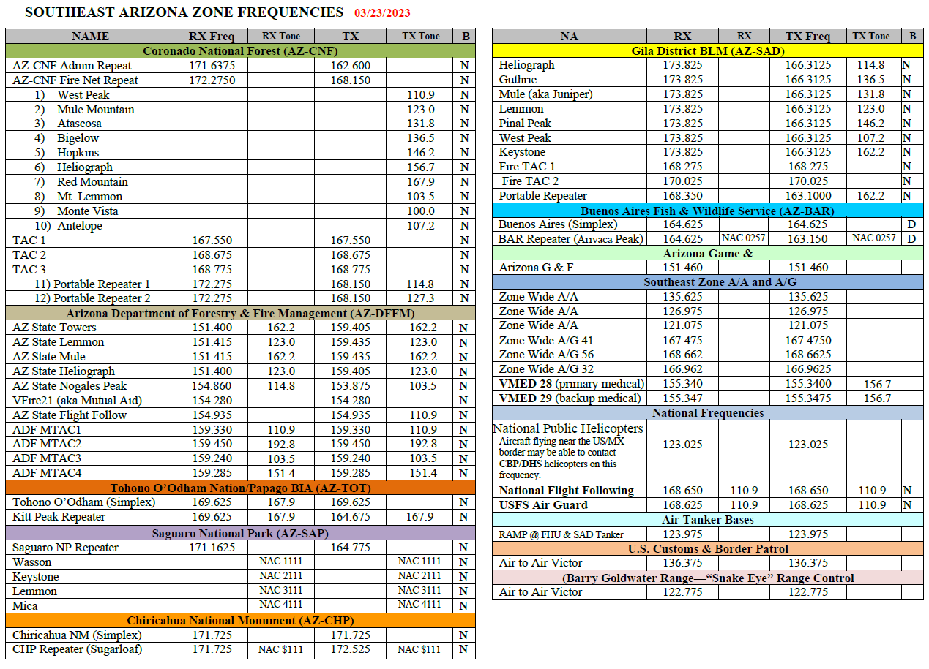

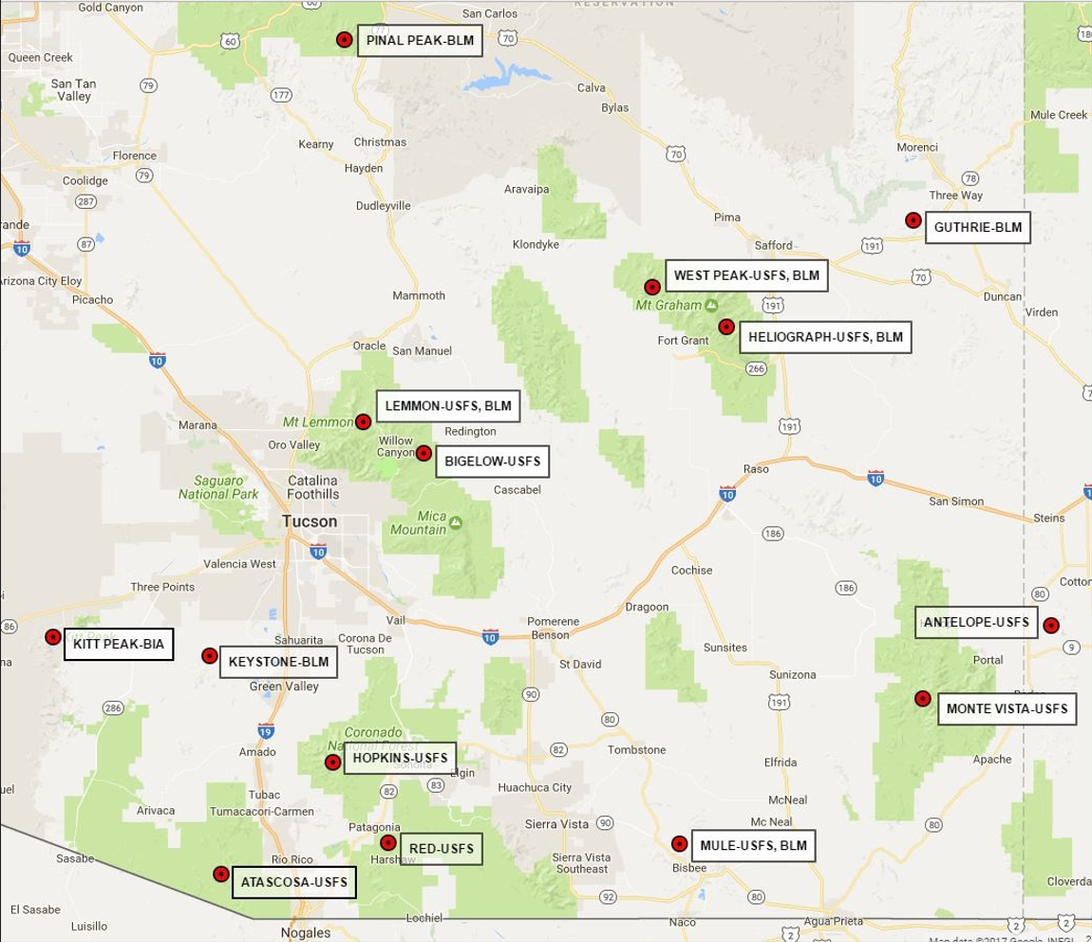

Local Cache
Nogales District has a local cache that can fill some supply orders. The cache can be reached by calling the District D.O. or his/her designee.

Tucson Simulation – Briefing for IADPs
Welcome to Tucson Interagency Dispatch in Tucson, Arizona. As you know, today is Thursday, June 22 and the clock on the wall is the correct time. We are in the Mountain Standard Time Zone.
Our area covers southern Arizona. As you read in the SOPs we provided you when you arrived yesterday, our GACC is the Southwest Coordination Center in Albuquerque, New Mexico.
We are an interagency dispatch and dispatch Forest Service, BLM, BIA, FWS and the NPS, using the closest forces concept.
Coronado National Forest, Papago Agency BIA/Tohono O’odham tribe, Gila District BLM, FWS—Buenos Aires NWR and San Bernadino NWR, and the NPS—Saguaro NP, Organ Pipe NM, and the Southern Arizona Group Parks.
We have six primary counties in our dispatch area: Pima, Pinal, Santa Cruz, Cochise, Graham, and Greenlee.
Mexico borders our dispatch area to the south. We do have an agreement in place with Mexico regarding wildland suppression. When there is an incident within ten miles of the border, if risk analysis and operation analysis support, US forces can cross the border to undertake suppression operations.
New Mexico state borders our dispatch area to the east. Silver City Dispatch Center (NM-SDC) is our neighboring dispatch center in NM.
Springerville Dispatch Center (AZ-SDC) is our neighboring dispatch center to the Northeast.
Phoenix Dispatch Center (AZ-PHC) is our dispatch neighbor to the North.
Prescott Dispatch (AZ-PDC) is our neighboring dispatch to the West.

Current Situation

We currently have the Oak fire going on. - ADD info on Oak. Weather has been hot and dry for over a month with no relief expected anytime soon.
A Cessna 182, N2919K, from Sonoran Desert Aircraft Services has been ordered today for a detection flight. They’ll be taking off Sierra Vista shortly and will call on Red.
This is a desert with a mountainous area mixed in. We have four lookouts within the dispatch area, but only three are staffed this summer: Mount Lemmon, Monte Vista, and West Peak.

When we get a smoke/fire report, we typically send the resources called for on the run card, and follow up with a call to the D.O.
Fire Codes are assigned, when needed, from WildCAD. In general, you will not need to, and are asked not to, pull codes from the FireCode system, or IROC.

Management
The Coronado NF FMO is Clyde Johnson.
The BLM FMO is Tim McGraw. The BLM has land in our dispatch area.

Our Resources
No resource orders need to be completed when mobilizing Coronado resources to a Coronado incident.
E-621 (Type 6 Engine) is available and currently at Nogales RD.
ENGB is Beckman. They are doing some project work today.
Tucson Regulars (20-person Type 2 IA crew) is available and currently here in Tucson.
CRWB is Sam Logue.
H-32MH (Type 3 helicopter – A-Star B3) with a 5-person helitack crew is available in Tucson.
We have three Law Enforcement Officers (LEOs) working today, 211, 212 and Coronado 10.
Be sure to only address them on the radio by call sign – NOT names.

SWCC Resources
These resources are available in Phoenix (Mesa-Gateway), which is approximately 150 miles north of Sierra Tank.
1 ASM
2 Airtankers (1 VLAT and 1 LAT)

Kneeboards are the preferred document to launch any aircraft.

IROC Resource orders are needed to order from SWCC. One may call and request first and follow up with an RO.

Incident Management Situation Report Thursday, June 22, 2023 – 0730 MDT National Preparedness Level 2
National Fire Activity:
Fire Activity and Teams Assigned | Total
Initial attack activity: | Light (80 fires)
New large incidents: | 2
Large fires contained: | 2
Uncontained large fires: ** | 7
Area Command teams committed: | 0
NIMOs committed: | 0
Type 1 IMTs committed: | 1
Type 2 IMTs committed: | 1
Complex IMTs committed: | 1

Nationally, there are five fires being managed under a strategy other than full suppression.
**Uncontained large fires only include fires being managed under a full suppression strategy.
GACC | Incidents | Cumulative Acres | Crews | Engines | Helicopters | Total Personnel | Change in Personnel
AICC | 2 | 495 | 3 | 3 | 1 | 80 | -13
NWCC | 8 | 30,072 | 11 | 60 | 2 | 508 | 9
ONCC | 0 | 0 | 0 | 0 | 0 | 0 | 0
OSCC | 1 | 3,792 | 14 | 16 | 0 | 490 | -19
NRCC | 0 | 0 | 0 | 0 | 0 | 0 | 0
GBCC | 1 | 614 | 0 | 20 | 0 | 73 | 0
SWCC | 7 | 58,424 | 9 | 28 | 7 | 733 | 157
RMCC | 0 | 0 | 0 | 0 | 0 | 0 | 0
EACC | 4 | 298 | 1 | 7 | 1 | 60 | -33
SACC | 6 | 23,002 | 1 | 24 | 4 | 216 | -21
Total | 29 | 116,697 | 39 | 158 | 15 | 2160 | 80
Three incident management teams, 22 fire suppression crews, 40 smokejumpers and 25 overhead personnel are assigned to large fire support in Canada.

Active Incident Resource Summary
Southwest Area (PL 3)
Fire Activity and Teams Assigned | Total
New fires: | 5
New large incidents: | 1
Uncontained large fires: | 3
Area Command teams committed: | 0
NIMOs committed: | 0
Type 1 IMTs committed: | 1
Type 2 IMTs committed: | 1

Rico, Las Cruces Field Office, BLM. (SW Team 1 mobilizing) One mile north of Pinos Altos, NM. Light slash and timber. Moderate fire behavior with flanking, backing, and creeping. Numerous structures and community of Pinos Altos threatened. Communication infrastructure threatened. Evacuations in effect.
McGregor, Las Cruces Field Office, BLM. Eight miles southeast of Timberon, NM. Short grass and brush. Moderate fire behavior with creeping.
Oak, Coronado NF, USFS. (SW Team 4) Eighteen miles northeast of Patagonia, AZ. Tall grass and brush. Minimal fire behavior. Demobilization occurring.
* Comanche, Carson NF, USFS. Ten miles southwest of El Rito, NM. Timber and brush. Moderate fire behavior with flanking, single tree torching and backing. Road closures in effect. Last narrative report unless significant activity occurs.
Wilbur, Coconino NF, USFS. Previously reported incident. Twenty-two miles east of Camp Verde, AZ. Timber. Moderate fire behavior with flanking, backing and group torching. Area and trail closures in effect. Last narrative report unless significant activity occurs.

Incident Name | Unit | Total Acres | Chge in Acres | % | Ctn/ Comp | Est | Total PPL | Chge in PPL | Crw | Eng | Heli | Strc Lost | $$ CTD | Origin Own
Rico | NM-LCD | 421 | 171 | 0 | Ctn | 6/30 | 270 | 28 | 5 | 14 | 5 | 0 | 1.5M | BLM
McGregor | NM-LCD | 678 | 0 | 90 | Ctn | 6/26 | 9 | -3 | 0 | 1 | 0 | 0 | 35K | BLM
Oak | AZ-CNF | 3,213 | 0 | 95 | Ctn | UNK | 256 | -32 | 4 | 6 | 0 | 0 | 1.2M | FS
* Comanche | NM-CAF | 399 | --- | 1 | Comp | 7/03 | 186 | --- | 3 | 7 | 1 | 0 | 1.6M | FS
Wilbur | AZ-COF | 7,942 | 7,468 | 41 | Comp | 7/15 | 131 | 8 | 3 | 9 | 1 | 0 | 1.8M | FS
Pass | NM-GNF | 53,090 | 499 | 13 | Comp | 9/30 | 76 | 8 | 1 | 2 | 1 | 0 | 3.4M | FS
Hull | AZ-KNF | 359 | --- | 5 | Comp | 7/31 | 72 | --- | 1 | 6 | 0 | 0 | 20K | FS
Ridge | AZ-KNF | 611 | --- | 3 | Comp | 8/31 | 61 | --- | 2 | 5 | 0 | 0 | 10K | FS

Predictive Services Discussion: Widespread dry and windy weather will spread across the Southwest, southern Great Basin, West Slope, and southeast California leading to elevated and critical fire weather conditions, including moderate to high-risk significant fire potential in the Southwest. Warm and dry conditions will persist in much of the Great Lakes, with minimum relative humidity below 35% in northern and western Michigan, northeast Minnesota, and northern Wisconsin, but thunderstorms are likely in much of Minnesota. Hot and dry conditions will continue across much of Texas into Louisiana with relative humidity below 20% in south and southwest Texas. Severe thunderstorms are likely on the eastern slopes of the central and southern Rockies onto the High Plains. Isolated thunderstorms are likely over the mountains in northern California and possibly in northern Washington. Scattered to widespread showers and thunderstorms are expected in much of the Southeast, southern Appalachians, and Mid-Atlantic, with thunderstorms extending into southeast Texas. Scattered showers are likely across the southern half to two-thirds of Alaska.

Fire Weather Planning Forecast for Southeast Arizona National Weather Service Tucson AZ
443 AM MST Thu Jun 22 2023

+++++++++++++++++++++++++++++++++++++++++++++++++++++++++++++++ 20-FOOT WIND FORECAST OF 'LIGHT WINDS' INDICATES MAINLY TERRAIN DRIVEN WINDS
+++++++++++++++++++++++++++++++++++++++++++++++++++++++++++++++

...Near critical conditions at times between 1400 and 1800 today in the higher terrain and to the east/southeast of Tucson...

.DISCUSSION...High temperatures will be within a couple of degrees of normal into Saturday, with a strong warming trend late in the weekend into early next week and highs soaring to 6-8 degrees above normal. Min RH values will be in the 3-9 percent range in the lower elevations and between 8-14 percent in the mountains into next week.

20-foot wind speeds will remain elevated, with near critical fire weather conditions at times in the higher terrain today and to the east/southeast of Tucson through at least early next week. Isolated locations in eastern Santa Cruz and Cochise counties may briefly exceed critical fire weather thresholds at times during the mid to late afternoon hours.
AZZ151-221115-
Arizona Fire Weather Zone 151
Western half Desert Grasslands FDRA including elevations up to 5500 feet in Southeast corner of Pinal County-
Extreme Eastern Pima County-Western third of Cochise County- Santa Cruz County-TDC-
443 AM MST Thu Jun 22 2023

.TODAY...
Sky/Weather..............Mostly sunny.
Max Temperature..........91 to 101 degs.
24 hr Trend...........Little change.
Min Humidity.............7 to 14 pct.
24 hr Trend...........Down 1 to 4 pct.
Wind (20 ft/10-min avg)..South around 10 mph becoming southwest
15 to 20 mph in the afternoon.
10000 ft MSL Wind........Southwest 30 to 35 mph.
Chance of Precip.........0 pct.
LAL. 1.
Haines Index.............5 or moderate.
Mixing Height............8362 ft agl.
Transport Winds..........South 21 to 27 knots.
Ventilation Category.....Excellent (225774 knot-ft).

.TONIGHT...
Sky/Weather..............Partly cloudy.
Min Temperature..........58 to 68 degs.
24 hr Trend...........Little change.
Max Humidity.............21 to 31 pct.
24 hr Trend...........Down 3 to 6 pct.
Wind (20 ft/10-min avg)..Southwest 15 to 20 mph.
10000 ft MSL Wind........Southwest 30 to 35 mph.
Chance of Precip.........0 pct.
LAL. 1.
Haines Index.............5 or moderate.

.FRIDAY...
Sky/Weather..............Partly cloudy then becoming mostly sunny.
Max Temperature..........90 to 100 degs.
24 hr Trend...........Little change.
Min Humidity.............5 to 11 pct.
24 hr Trend...........Down 1 to 4 pct.
Wind (20 ft/10-min avg)..Southwest 15 to 20 mph.
10000 ft MSL Wind........Southwest 30 to 35 mph.
Chance of Precip.........0 pct.
LAL. 1.
Haines Index.............5 or moderate.
Mixing Height............7706 ft agl.
Transport Winds..........Southwest 19 to 27 knots.
Ventilation Category.....Excellent (208062 knot-ft).

.FORECAST DAYS 3 THROUGH 7...
WINDS IN DAYS 3 THROUGH 5 ARE SURFACE 20 FT/10-MIN AVG
.SATURDAY...Clear. Lows 56 to 66. Highs 93 to 103. Southwest wind
around 20 mph. Minimum Humidity 4 to 11 pct.
.SUNDAY...Clear. Lows 60 to 70. Highs 97 to 107. Southwest wind
around 15 mph. Minimum Humidity 4 to 11 pct.
.MONDAY...Mostly clear. Lows 62 to 72. Highs 99 to 109. West wind
around 15 mph. Minimum Humidity 5 to 12 pct.
.TUESDAY...Mostly clear. Lows 64 to 74. Highs 98 to 108.
.WEDNESDAY...Mostly clear. Lows 64 to 74. Highs 97 to 107.

NOTE TO USERS - ZONE 151 VENTILATION CATEGORY...MIXING HEIGHT AND TRANSPORT WINDS ARE BASED ON THE BUENOS AIRES N.W.R. LOCATION (3500 MSL)

Tucson Simulation
Input Sequence Summary
Part 1
Input Number | Method | Action
1 | Radio (Green) | PREV 5-5 check-in
2 | Radio (Red) | AA 305 check-in
3 | Radio (Green) | Atascosa Lookout smoke report
4 | Telephone | AZ Dispatch (neighbor) reports same fire
5 | Telephone | Nogales D.O. asks fire status, aircraft availability
6 | Radio (Red) | Air Attack initial size-up, resource requests
7 | Radio (Green) | Oak Fire IC, resource demob/availability
8 | Telephone | GACC (SWCC) Aircraft Desk Inquiry
9 | Radio (Green) | Jones (IHC Sup) takes command, full-size up, resource info, spot forecast
10 | Radio (Green) | Campground Host reports bee sting, ambulance
11 | Radio (Green) | Engine 321 flat tire
12 | Radio (Green) | Jones IC requests Fire Investigator
13 | Radio (Green) | Jones IC reports border crossing activity
14 | Telephone | GACC (SWCC) smoke report, neighboring jurisdiction

D311 Tucson Simulation
Input Worksheet – Part 1
Input # | Resource | Role Assignment | Completed   | Time (Optional)
1
2
3
4
5
6
7
8
9
10
11
12
13
14

Feedback Response Roles
Resource | Role Assignment
INPUT NUMBER: 1

FROM: PREV (XX)
DELIVER TO: Tucson Dispatch
BY: Radio, Green Frequency

MESSAGE: “Tucson Dispatch, this is PREV 5-5 on Green” (await confirmation)
“PREV 5-5 in service to Mt. Lemmon”

FOLLOW UP ACTION:
IADP responds to resource.
IADP records resource in service (CAD).
IADP indicates resource location on Map/CAD.

POTENTIAL QUESTIONS FROM STUDENTS:
Where is Mt. Lemmon? (Do we need location info if we’re in CAD? That is, we can/should be searching in CAD)
Does this resource have fire quals? Yes, FFT2/INVF Availability? Yes, available.

INPUT NUMBER: 2

FROM: AA 305
DELIVER TO: Tucson Dispatch
BY: Radio, Red Frequency

MESSAGE: “Tucson Dispatch, AA 305” (await confirmation), “AA 305 completed recon of Huachuca Mountains and enroute Chiricahua Mountains”

FOLLOW UP ACTION:
Student records conversation (CAD) and begins flight following.

POTENTIAL QUESTIONS FROM STUDENTS:

INPUT NUMBER: 3

FROM: Atascosa Lookout
DELIVER TO: Tucson Dispatch
BY: Radio, Green Frequency

MESSAGE: “Tucson Dispatch, Atascosa Lookout on Green” (await confirmation) “I have a smoke report when you’re ready” (await confirmation) “I’m seeing a light, white smoke at … Need to develop this Lookout’s Smoke Report. And any initial actions below keeping in mind D.O. conversation in Input 5 and AA response and associated resource requests on Input 6

FOLLOW UP ACTION:

POTENTIAL QUESTIONS FROM STUDENTS:

INPUT NUMBER: 4

FROM: Joe at Arizona Dispatch - Mike
DELIVER TO: Tucson Dispatch
BY: Telephone

MESSAGE: “I got a report of a smoke South of Arivaca Lake, do you know anything about that?”
FOLLOW UP ACTION:

POTENTIAL QUESTIONS FROM STUDENTS:

INPUT NUMBER: 5

FROM: Nogales Duty Office Tyler
DELIVER TO: Tucson Dispatch
BY: Telephone

MESSAGE: “Heard on the radio there’s a new smoke South of Arivaca Lake? (Student responds with details) “Do we have any aircraft in the area that can respond?”

FOLLOW UP ACTION:
Floor CORD updates Duty Officer on known size-up information.
Floor CORD informs D.O. of AA 305 availability.
Floor CORD instructs IADP for AA 305 assignment to new I.A.
IADP gives assignment information to AA 305 on Red

POTENTIAL QUESTIONS FROM STUDENTS:

INPUT NUMBER: 6

FROM: AA 305
DELIVER TO: Tucson Dispatch
BY: Radio, Red Frequency

MESSAGE: “Tucson Dispatch, AA 305 on Red” (await confirmation) “On scene Incident 400, I have size-up info when you’re ready” (await confirmation) “AA-305 develop size up info” (await confirmation) “I am requesting a T-3 Helicopter, 2 Engines, and a Crew to respond to this incident”

FOLLOW UP ACTION:

POTENTIAL QUESTIONS FROM STUDENTS:

INPUT NUMBER: 7

FROM: Maverick Fire IC
DELIVER TO: Tucson Dispatch
BY: Radio, Green Frequency

MESSAGE: “Our fire is winding down, I heard you have a new fire? If you need any engines, I could make them available.”

FOLLOW UP ACTION:

POTENTIAL QUESTIONS FROM STUDENTS:

INPUT NUMBER: 8

FROM: SWCC Aircraft
DELIVER TO: Tucson Dispatch
BY: Telephone

MESSAGE: “I see AA 305 is flying, anything happening? Any needs?”

FOLLOW UP ACTION:
Student briefs SWCC on situation and needs reported by AA 305

POTENTIAL QUESTIONS FROM STUDENTS:

INPUT NUMBER: 9

FROM: Aravaipa IHC Superintendent Jim Jones
DELIVER TO: Tucson Dispatch
BY: Radio, Green Frequency

MESSAGE: “On scene at the 400 incident and will be taking over command at this time. I have a size-up when you’re ready to copy” (await confirmation) “Insert full size up here” (Create Size-up form for inputter) (await confirmation) “What resources are coming and what is the name of the fire?” (await confirmation) “I would also like to request a spot weather forecast at this time.”

FOLLOW UP ACTION:
IADP records size-up information (CAD).
Floor CORD delegate spot weather to Logs.
Plotter locates fire on map/CAD, establishes fire name “Sierra Tank”.
IADP communicates fire name to IC/AA
IADP communicates resources mobilized.

POTENTIAL QUESTIONS FROM STUDENTS:

INPUT NUMBER: 10

FROM: Parker Canyon Lake Campground Host
DELIVER TO: Tucson Dispatch
BY: Radio, Green Frequency

MESSAGE: “I have a camper that was stung by a bee. He is in his mid-40s, he is not having a bad reaction currently, but he has in the past. To be safe, the family has requested he be seen by medical personnel. Can you get an ambulance headed this way?”

FOLLOW UP ACTION:
IADP records the incident (CAD)
IADP makes notification to County, notifies CORD
IADP follow-up with Campground Host, ETA

POTENTIAL QUESTIONS FROM STUDENTS:

INPUT NUMBER: 11

FROM: ENG 321
DELIVER TO: Tucson Dispatch
BY: Radio, Green Frequency

MESSAGE: “Tucson Dispatch, Engine 321 on Green” (await confirmation) “We have a flat tire while enroute from Oak to the Sierra Tank incident. We will be delayed in responding to the incident.”

FOLLOW UP ACTION:
IADP records information.
IADP asks if any assistance is needed.
IADP asks how long of delay.
IADP relays to the IC (IC wants replacement engine).
FACILITATOR: Are any other engines on scene? (Arivaca FD Engine)

POTENTIAL QUESTIONS FROM STUDENTS:
How long is the delay? (Estimating 45 mins)
Will you need a replacement? (Yes) (Arivaca FD Engine)

INPUT NUMBER: 12

FROM: Sierra Tank IC
DELIVER TO: Tucson Dispatch
BY: Radio, Green Frequency

MESSAGE: “Can you order me a Fire Investigator please?’

FOLLOW UP ACTIONS:
IADP asks follow-up information as date and time needed, location, etc.
IADP should recall that PREV 5-5 (with FINV qual) is available and in the field.
IADP contacts PREV 5-5
PREV 5-5 (Role Player) responds “I’ll have to get back to you. I may not be available until tomorrow”.
IADP initiates dialog with IC on if needed sooner.

POTENTIAL QUESTIONS FROM STUDENTS:

INPUT NUMBER: 13

FROM: Sierra Tank IC
DELIVER TO: Tucson Dispatch
BY: Radio, Green Frequency

MESSAGE: “Yea Tucson, we are seeing a group of individuals who have come across the border leaving the fire area. Can you call Border Patrol please?”

FOLLOW UP ACTION:
IADP calls Border Patrol and relays information.

POTENTIAL QUESTIONS FROM STUDENTS:
Which direction were they moving? (Northeast)
How many? (30)
What were they wearing? (Camouflage)

INPUT NUMBER: 14

FROM: SWCC Aircraft Desk
DELIVER TO: Tucson Dispatch
BY: Telephone

MESSAGE: “We have a smoke report for you. Reported from ABQ ARTCC (Need to insert VOR radial distance here that puts it roadside AZS jurisdiction) “Pilot reported the fire is approximately 1 acre in size, appears to be on the North side of I-10.”

FOLLOW UP ACTION:
IADP calls Arizona Dispatch Center, passes known information.

POTENTIAL QUESTIONS FROM STUDENTS:
Was anyone on scene? (No)
Was it a vehicle fire? (No)
Was it affecting traffic on I-10? (No, fire is on North side and moving away from Interstate)

END OF PART 1
Tucson Simulation
Input Sequence Summary
Part 2
Input Number | Method | Action
15 | Radio (Green) | Atascosa Lookout checking in, winds picking up
16 | Radio (Red) | H-320 off Maverick Helibase enroute Sierra Tank
17 | Radio (Green) | FS LEO in service, enroute Sierra Tank
18 | Radio (Green) | Citizen traffic on Ruby Road, need traffic control
19 | Telephone | NWS Tucson Spot Weather forecast complete, communication on winds
20 | Radio (Green) | Sierra Tank IC ordering security for ICP
21 | Radio (Red) | AA 305 ordering additional aircraft
22 | Radio (Green) | Parker Canyon C.G. host, ambulance arrival confirmation
23 | Telephone | Local T-3 IMT IC inquiry about Sierra Tank, organizational planning
24 | Telephone | Concerned citizen inquiry about Sierra Tank, PIO engagement
25 | Radio (Red) | AA 305 reporting another smoke visible from Sierra Tank
26 | Radio (Green) | Sierra Tank IC orders Water Tender
27 | Telephone | District Duty Officer ordering supplies for the District
28 | Radio (Green) | Sierra Tank IC reports medical event

D311 Tucson Simulation
Input Worksheet – Part 2
Input # | Resource | Role Assignment | Completed | Time (Optional)
1
2
3
4
5
6
7
8
9
10
11
12
13
14

Feedback Response Roles
Resource | Role Assignment
INPUT NUMBER: 15

FROM: Atascosa Lookout
DELIVER TO: Tucson Dispatch
BY: Radio, Green Frequency

MESSAGE: Tucson Dispatch, Atascosa Lookout on Green (await confirmation).
Yea Tucson, I wanted to let you know that winds have increased in last 30 minutes or so. Showing sustained winds 15-20 mph out of the South currently.

FOLLOW UP ACTION:
IADP confirms IC heard the traffic. (IC Role-player - did not hear… IADP repeats message from lookout)

POTENTIAL QUESTIONS FROM STUDENTS:

INPUT NUMBER: 16

FROM: H-320
DELIVER TO: Tucson Dispatch
BY: Radio, Red Frequency

MESSAGE: Tucson Dispatch, H-320 on Red (await confirmation). H-320 off Maverick Helibase enroute Sierra Tank, 4 SOB, 2+30 fuel, 15 min ete

FOLLOW UP ACTION:
IADP confirm that AA 305 heard the traffic (yes, they did)
IADP starts flight following.

POTENTIAL QUESTIONS FROM STUDENTS:
Are you going to work out of Maverick helibase? (yes, they will)
Are there other aircraft on scene?

INPUT NUMBER: 17

FROM: FS 210
DELIVER TO: Tucson Dispatch
BY: Radio, Green Frequency

MESSAGE: Tucson Dispatch, FS 210 on Green (await confirmation). FS 210 in service, enroute Sierra Tank. I am estimating 45 mins travel.

FOLLOW UP ACTION:
IADP initiates resource tracking (CAD)
POTENTIAL QUESTIONS FROM STUDENTS:
Is he assigned to the fire? (No)
Does he have any red card qualifications? (SEC1?)

INPUT NUMBER: 18

FROM: FS 210
DELIVER TO: Tucson Dispatch
BY: Radio, Green Frequency

MESSAGE: Tucson Dispatch, FS 210 on Green (await confirmation). I am seeing a lot of citizen traffic along Ruby Rd. Can you get some traffic control out here?

FOLLOW UP ACTION:
Facilitator (Is this in SOPs? may need to help this along)
IADP initiates this with Santa Cruz County.
IADP follow-up with FS 210.
POTENTIAL QUESTIONS FROM STUDENTS:
Which side of Ruby Rd needs traffic control? (West side near the town of Arivaca)

INPUT NUMBER: 19

FROM: Gary from Tucson Weather Service
DELIVER TO: Tucson Dispatch
BY: Telephone

MESSAGE: I have your Sierra Tank spot weather forecast complete and posted to the site. I also wanted to let you know that we are seeing the winds pick up and are forecasted to stay that way all afternoon into the evening in the fire area. Showing sustained up to 20 mph with higher gusts.
FOLLOW UP ACTION:
IADP contacts Sierra Tank IC on Green. Reads the spot weather forecast (Develop this)
POTENTIAL QUESTIONS FROM STUDENTS:
IADP asks the IC if he also wants the Spot emailed to him for documentation.
When would you like another spot for the fire area to be submitted?

INPUT NUMBER: 20

FROM: Sierra Tank IC
DELIVER TO: Tucson Dispatch
BY: Radio, Green Frequency

MESSAGE: Tucson Dispatch, Sierra Tank IC on Green (await confirmation). It looks like we might be out late tonight. Can you arrange for some security at ICP?

FOLLOW UP ACTION:
IADP follows up with FS 210 if he is available for SEC1 assignment (yes, he can be).
POTENTIAL QUESTIONS FROM STUDENTS:
Does it need to be SEC1 (with gun)? (Yes)
Is 1 SEC1 enough for ICP security?

INPUT NUMBER: 21

FROM: AA 305
DELIVER TO: Tucson Dispatch
BY: Radio, Red Frequency

MESSAGE: Tucson Dispatch, AA 305 on Red (await confirmation). Tucson, I’m gonna need to order 1 LAT, 2 SEATs, and a relief Air Attack.

FOLLOW UP ACTION:
Facilitator or SOP resource briefing
IADP initiates call to ADC (neighbor) for SEATs
IADP initiates call to GACC for LAT and relief Air Attack
POTENTIAL QUESTIONS FROM STUDENTS:
What about a Lead or ASM?
What about a TFR? Frequencies?
What time for relief? (in 1.5 hours)

INPUT NUMBER: 22

FROM: Parker Canyon Lake Campground Host
DELIVER TO: Tucson Dispatch
BY: Radio, Green Frequency

MESSAGE: Tucson Dispatch, Parker Canyon Lake Campground on Green (await confirmation). The ambulance has arrived on scene to care for our patient.

FOLLOW UP ACTION:
IADP updates medical incident (CAD)
POTENTIAL QUESTIONS FROM STUDENTS:
Who needs to be notified about this medical incident?

INPUT NUMBER: 23

FROM: Rusty IC from local IMT3
DELIVER TO: Tucson Dispatch
BY: Telephone

MESSAGE: Are they gonna order a team for this new fire? We are available!

FOLLOW UP ACTION:
IADP responds accordingly.
Facilitator – No decision yet on whether Sierra Tank will be ordering a Team.

POTENTIAL QUESTIONS FROM STUDENTS:

INPUT NUMBER: 24

FROM: Pamela (Citizen)
DELIVER TO: Tucson Dispatch
BY: Telephone

MESSAGE: I live in Tucson, but I have some land South or Arivaca. Are you getting that fire put out?

FOLLOW UP ACTION:
IADP should pass this to the forest PIO (capture in SOPs)

POTENTIAL QUESTIONS FROM STUDENTS
Preferrable ask the citizen to call the PIO direct instead of forward… Ask PIO if number is avail for public or if we must gather information and they call them back?

INPUT NUMBER: 25

FROM: AA 305
DELIVER TO: Tucson Dispatch
BY: Radio, Red Frequency

MESSAGE: Tucson Dispatch, AA 305 on Red (await confirmation). Yea Tucson, I see a smoke down South near the Mexico border. Looks like it may be in Mexico but starting to build a pretty good column.

FOLLOW UP ACTION:
IADP follow-up with D.O. on the District
Can AA 305 break away from Sierra Tank to go look at it? (No)
IADP initiates order for AA with GACC (could involve the relief AA initially ordered earlier?)
POTENTIAL QUESTIONS FROM STUDENTS:
What color is it? (White)

INPUT NUMBER: 26

FROM: Sierra Tank IC
DELIVER TO: Tucson Dispatch
BY: Radio, Green Frequency

MESSAGE: Tucson Dispatch, Sierra Tank IC on Green (await confirmation). I need to order a Water Tender out here.

FOLLOW UP ACTION:
IADP asks Water Tender type, date and time needed, and reporting location.
IADP engages logistics.
POTENTIAL QUESTIONS FROM STUDENTS:
Are there any Agency Tenders available? (No)
Is contract (VIPR) OK?
Do any of the local FD’s have a Water Tender available?

INPUT NUMBER: 27

FROM: Nogales Duty Office Tyler
DELIVER TO: Tucson Dispatch
BY: Telephone

MESSAGE: I’m gonna need to order some supplies for the District with this Sierra Tank fire going on. Can you order me a pallet each of MRE’s, water, and Gatorade.
FOLLOW UP ACTION:
IADP engages logistics.

POTENTIAL QUESTIONS FROM STUDENTS:
Can you send me a General Message with this information on it?
What is this charged to? (Sierra Tank)
Who is paying for this? (local procurement personnel)
Where is deliver point (District)
When? (1600)

INPUT NUMBER: 28

FROM: Sierra Tank IC
DELIVER TO: Tucson Dispatch
BY: Radio, Green Frequency

MESSAGE: Tucson Dispatch, Sierra Tank IC on Green (await confirmation). Yea Tucson, we have a yellow medical going on out here. Appears to be related to heat exhaustion. Standby for Medical Incident Report… (await confirmation).
**Role Player (IC) gives MIR info** (await confirmation)

FOLLOW UP ACTION:
IADP should open new incident (CAD).
IADP engages in dialog with IC as to recommended transport (ground)
IADP engages with logs/Santa Cruz County
Notification to Duty Officer
Notification to individual’s appropriate Agency

POTENTIAL QUESTIONS FROM STUDENTS:
Who is the person? (Arivaca FD Engine Crew Member)
Need for Hospital Liaison (Yes, this gets coordinated with individual’s home unit)

END SIMULATION HERE

